***Prior Knowledge***

*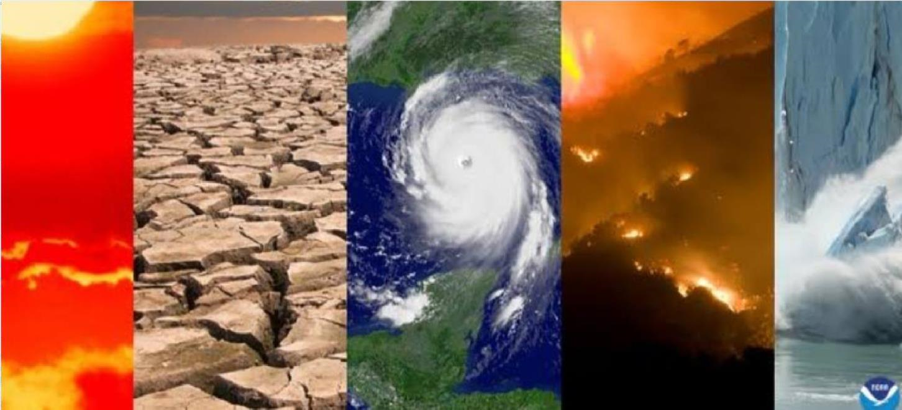****Natural disasters intensity analysis and classification using artificial intelligence***

* Being prepared can reduce fear, anxiety, and losses that accompany disasters. Communities, families, and individuals should know what to do in the event of a fire and where to seek shelter during a powerful storm. They should be ready to evacuate their homes and take refuge in public shelters and know how to care for their basic medical needs.
* People also can reduce the impact of disasters (flood proofing, elevating a home or moving a home out of harm’s way, and securing items that could shake loose in an earthquake) and sometimes avoid the danger completely.
* You should know how to respond to severe weather or any disaster that could occur in your area – hurricanes, earthquakes, extreme cold, flooding, or terrorism.
* You should also be ready to be self-sufficient for at least three days. This may mean providing for your own shelter, first aid, food, water, and sanitation.
* There are many types of disasters and emergencies: fires, floods, earthquakes or manmade disasters. You and your family may need to survive on your own after an emergency. Having sufficient supplies such as food, water, medicine and emergency essentials is important. Local officials and relief workers will be on the scene after a disaster but they cannot reach everyone immediately. You could get help in hours or it might take days. It is estimated that after a major disaster, it may take up to three days for relief workers to reach some areas

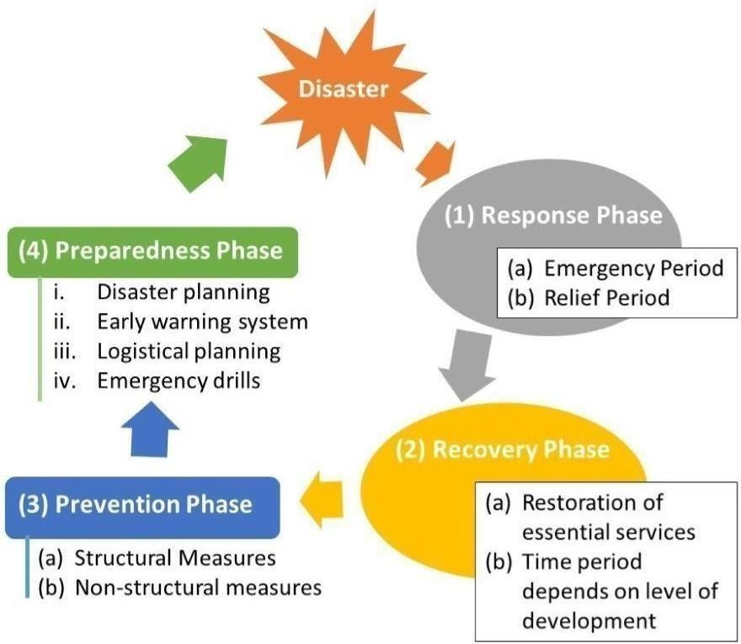

**Basic Disaster Supplies Kit**

**The following items are recommended for inclusion in your basic disaster supplies kit:**

* A three-day supply of non-perishable food suitable for your family’s size
* A three-day supply of water – one gallon of water per person, per day
* Portable, battery-powered radio or television and extra batteries
* Flashlight and extra batteries
* First aid kit and manual
* Sanitation and hygiene items (moist towelettes and toilet paper)
* Matches and a waterproof container
* Whistle
* Extra clothing

Kitchen accessories and cooking utensils, including a can opener

* Photocopies of credit and identification cards
* Cash and coins
* Special needs items, such as prescription medications, eye glasses, contact lens
* Solution, and hearing aid batteries
* Items for infants, such as formula, diapers, bottles, and pacifiers
* Other items to meet your unique family needs

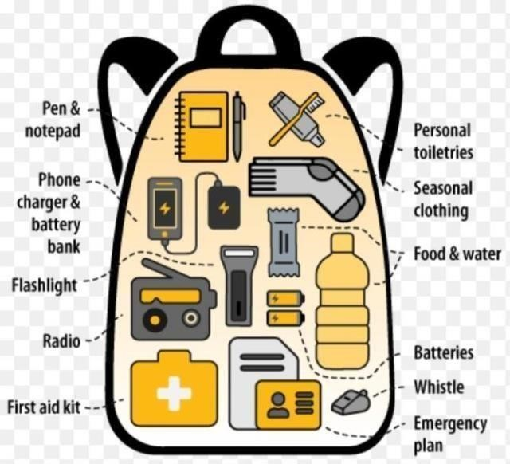

# Submitted by:-

## Rajesh B (721419106029) Praneel.S.Sundar (721419106026) Mohammed Ziyad (721419106023)

## Rahul K Nair (721419106028)

## Adarsh S (721419106002)

**Team ID**:- PNT2022TMID43723